# Theory:

## DDL Commands in SQL

Data Definition Language(DDL) is a subset of SQL and a part of DBMS(Database Management System). DDL consist of Commands to commands like CREATE, ALTER, TRUNCATE and DROP. These commands are used to create or modify the tables in SQL.

## DDL Commands :

In this section, we will cover the following DDL commands as follows.

1. Create
2. Alter
3. Truncate
4. Drop
5. Rename

The DDL Commands in Structured Query Language are used to create and modify the schema of the database and its objects. The syntax of DDL commands is predefined for describing the data. The commands of Data Definition Language deal with how the data should exist in the database.

## CREATE Command -

CREATE is a DDL command used to create databases, tables, triggers and other database objects. CREATE command is a SQL (Structured Query Language) command used to create a new database, table, index, view, or stored procedure. The syntax for the CREATE command varies depending on what you are trying to create.

## ALTER Command -

In SQL (Structured Query Language), ALTER command is used to modify or change the structure of a database object such as a table, view, or procedure.The ALTER command can be used to perform a variety of tasks, such as adding or dropping a column, renaming a column, changing the data type of a column, adding or dropping a constraint, and renaming an object.

## TRUNCATE Command -

In SQL (Structured Query Language), TRUNCATE command is used to delete all the data from a table, while keeping the table structure intact. TRUNCATE is a DDL (Data Definition Language) command and is used to remove all the rows from a table in a single shot.The TRUNCATE command is faster than the DELETE command because it does not log individual row deletions. When you use the TRUNCATE command, the operation is non-transactional, which means that you cannot rollback the operation.

## DROP Command -

In SQL (Structured Query Language), DROP command is used to delete or remove a database object such as a table, view, or procedure from the database. The DROP command is a DDL (Data Definition Language) command and is used to permanently remove an object from the database.

# Code :

## Table 1.

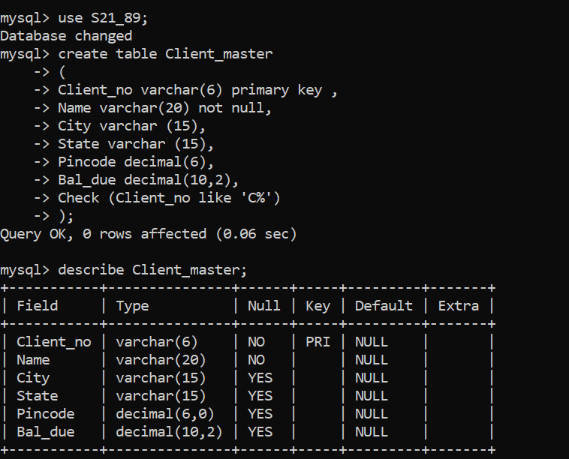

## Table 2.

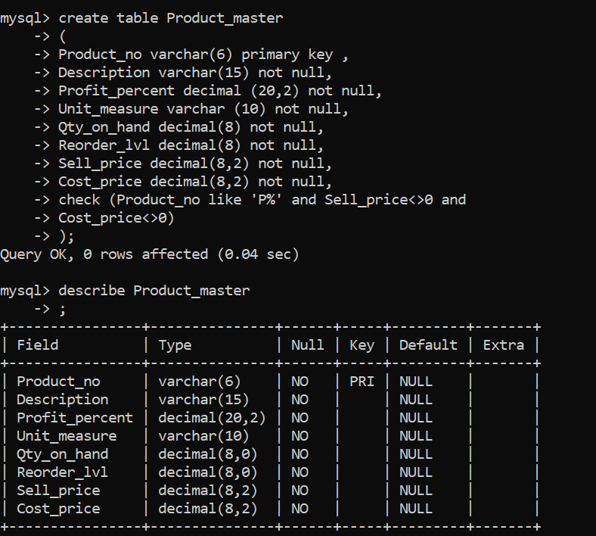

## Table 3.

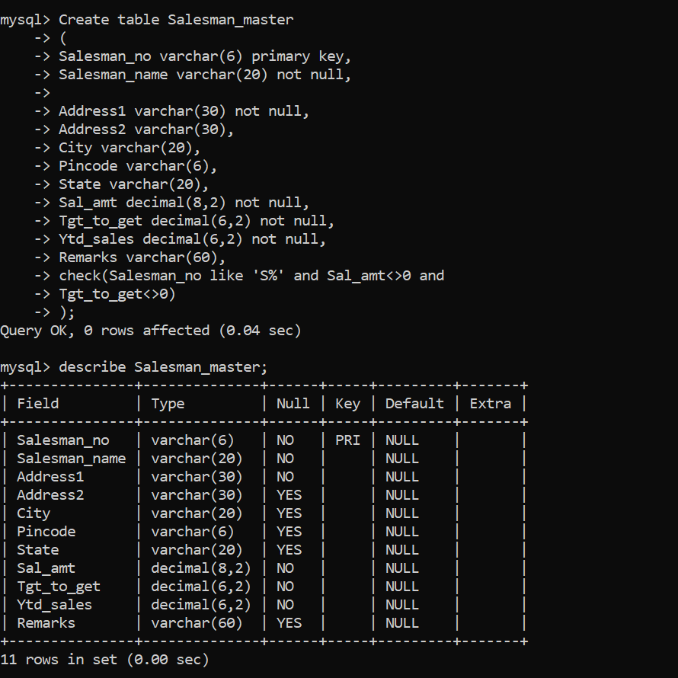

## Table 4.

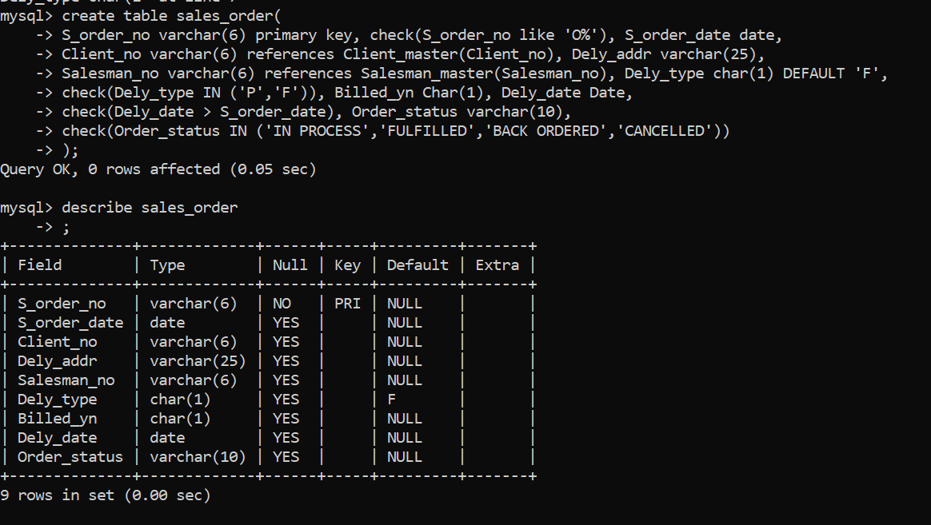

## Table 5

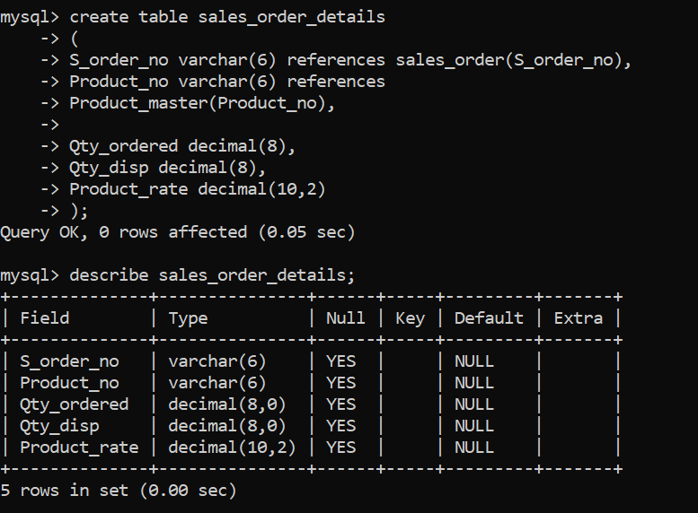

## Table 6.

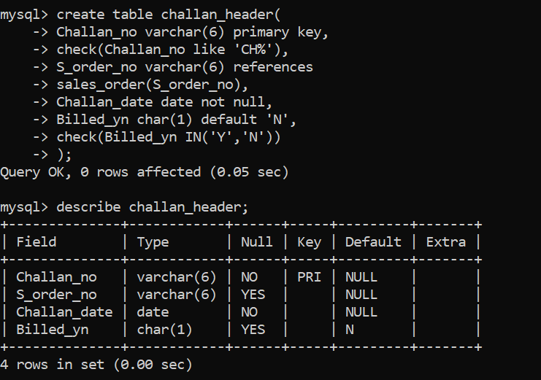

## Table 7.

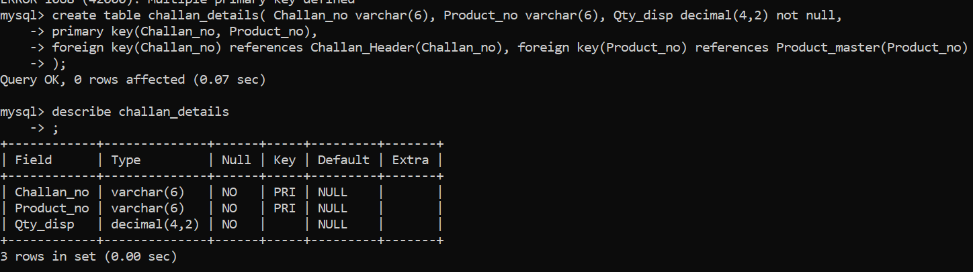

**Conclusion** :

The experiment is completed and

LO2 is mapped.